Assignment -4

Docker and Kubernetes

|  |  |
| --- | --- |
| Assignment Date | 21 October 2022 |
| Student Name | PRANAV DEVI R. |
| Student Roll Number | CITC19 05 036 |
| Maximum Marks | 2 Marks |

1. **Pull an image from docker hub and run it in docker Playground**

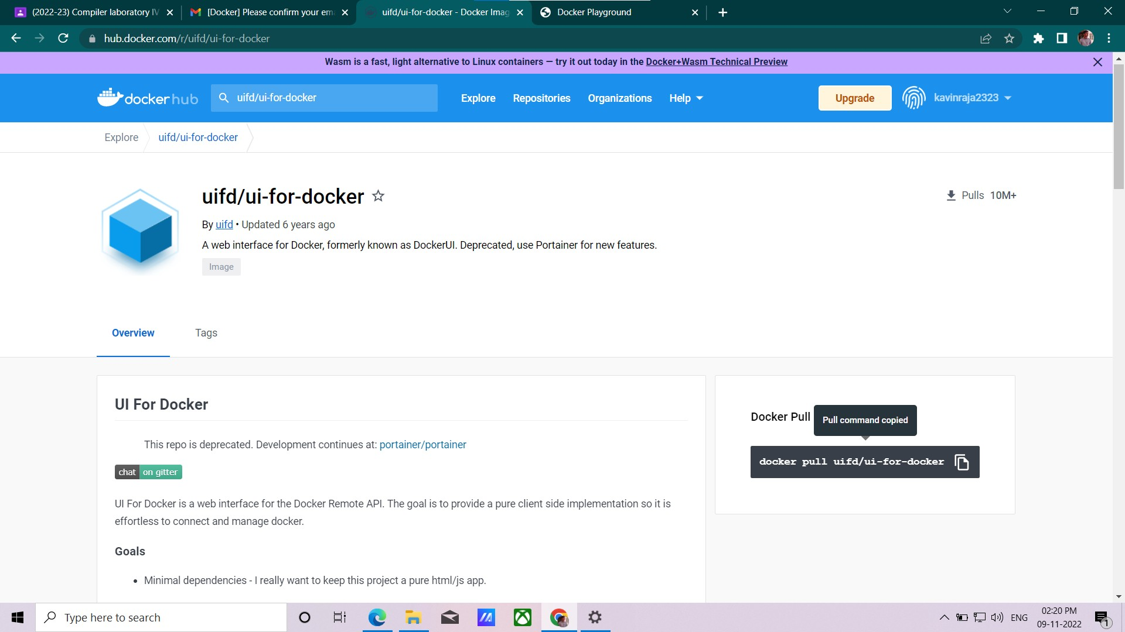

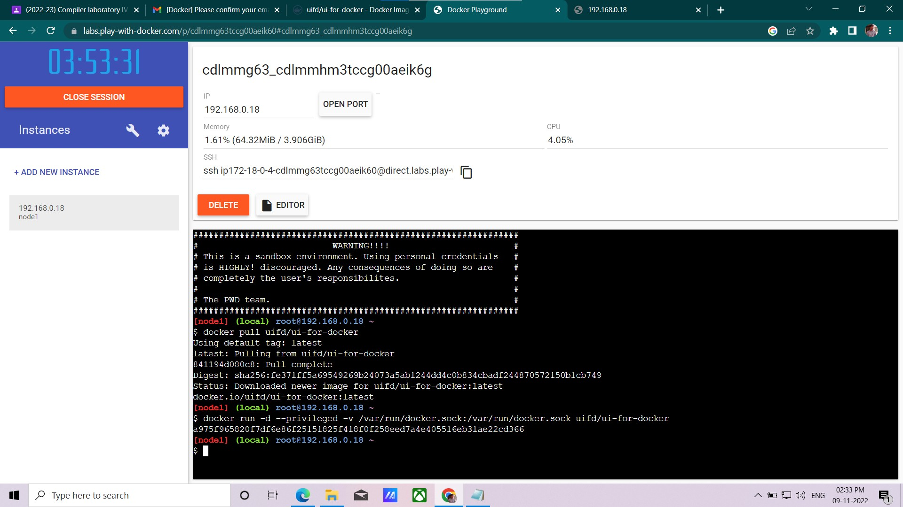

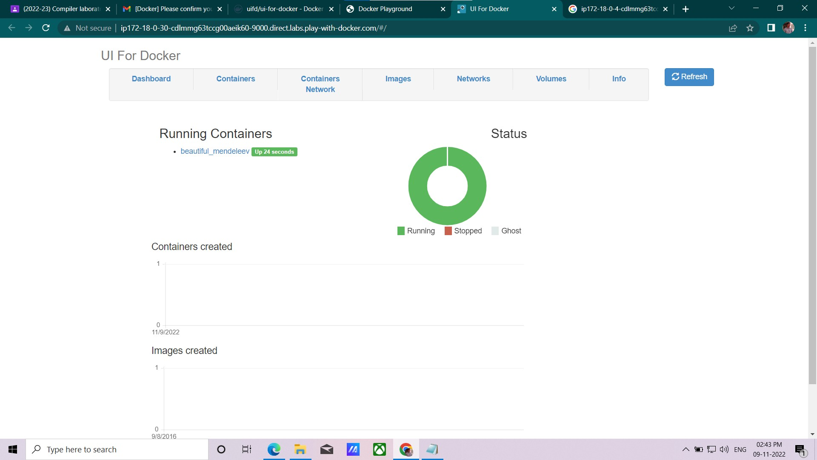

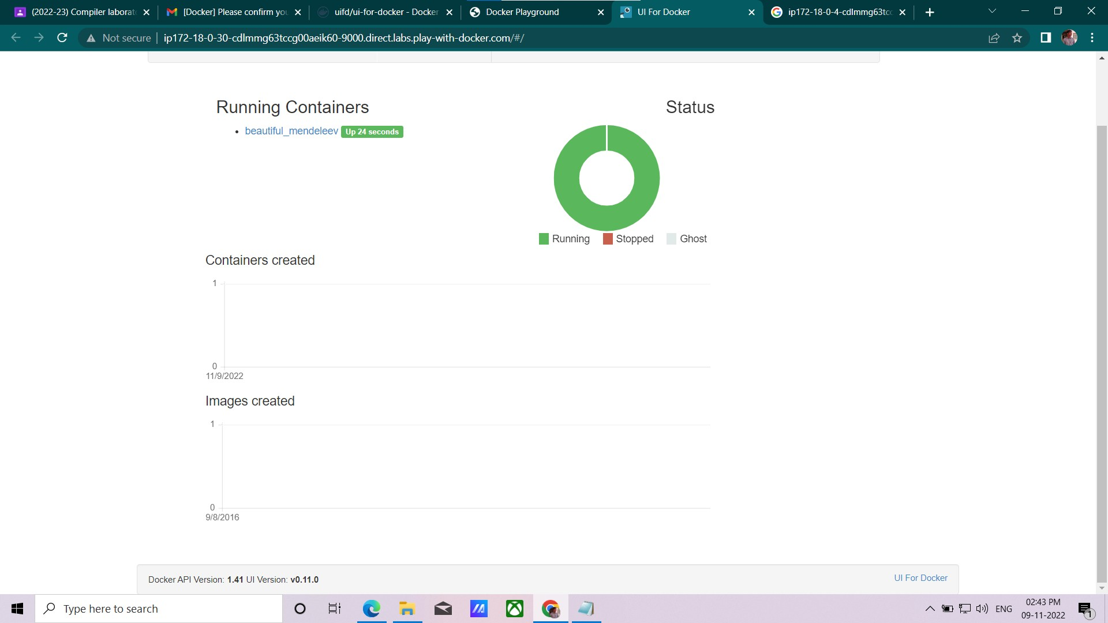

1. **Create a docker file for the job portal application and deploy it in Docker desktop application**

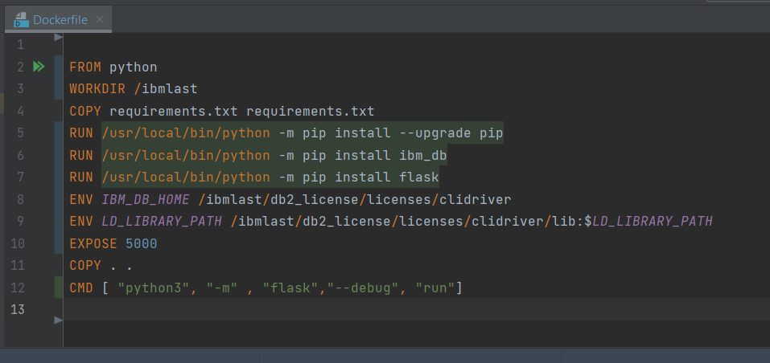

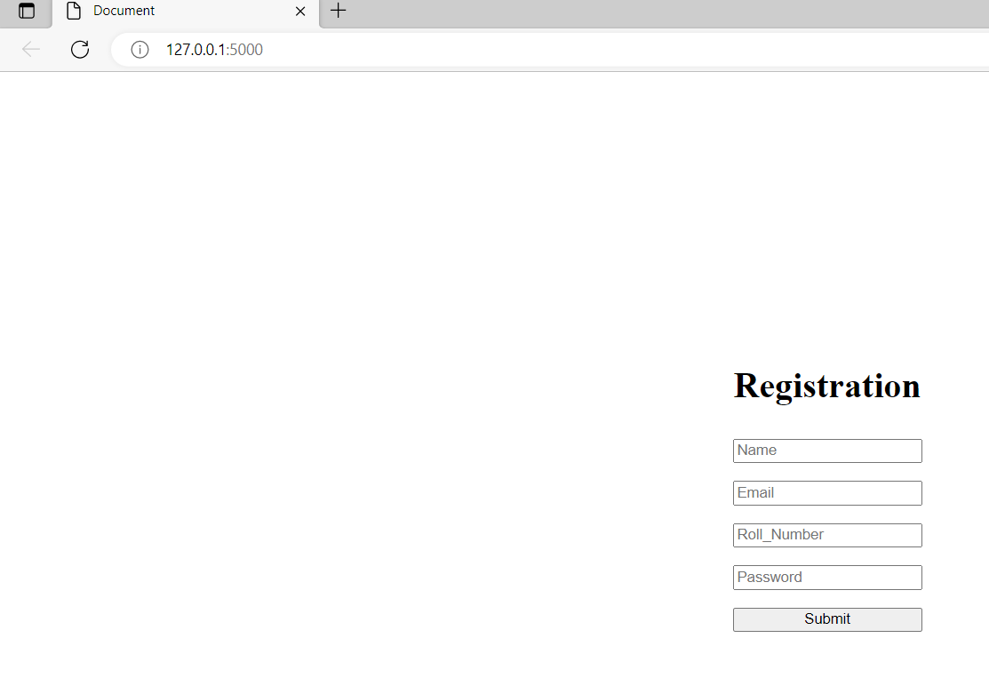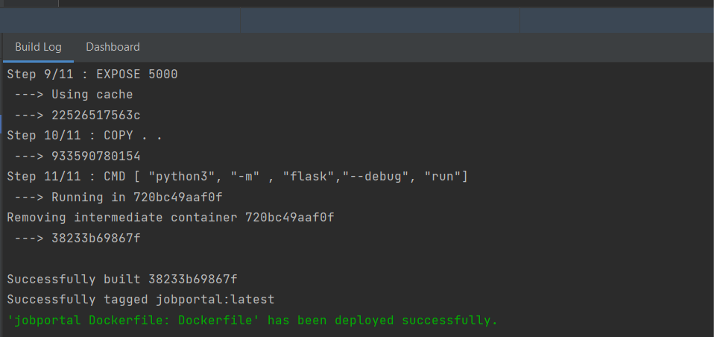

3.Create a IBM container registry and deploy helloword app

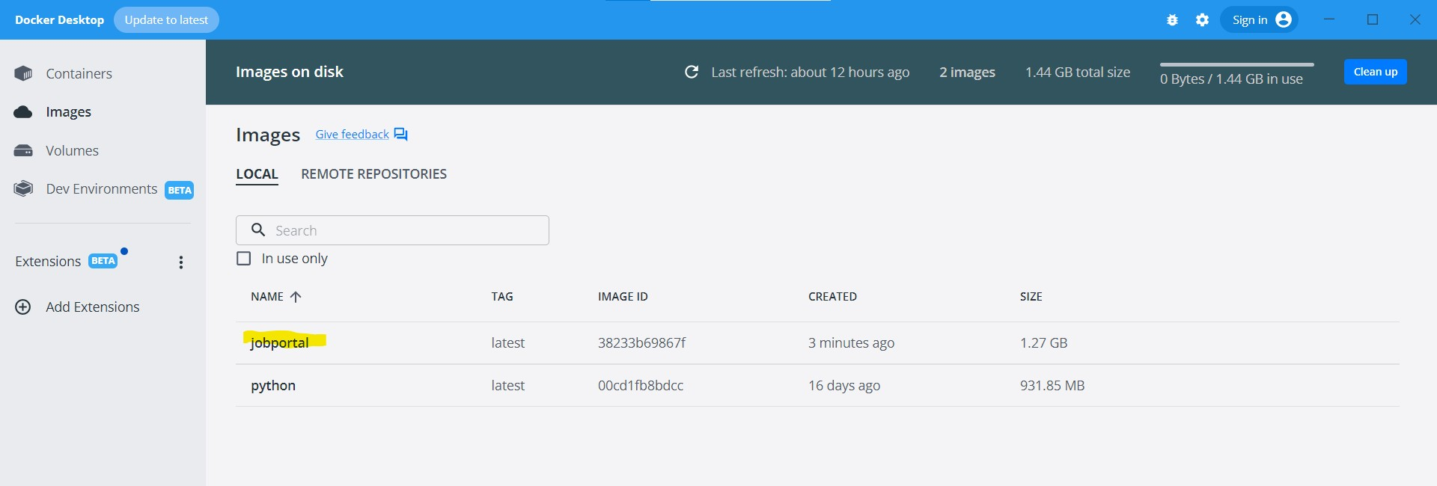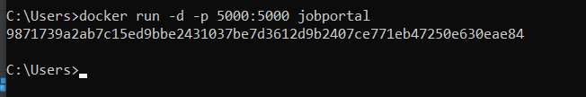

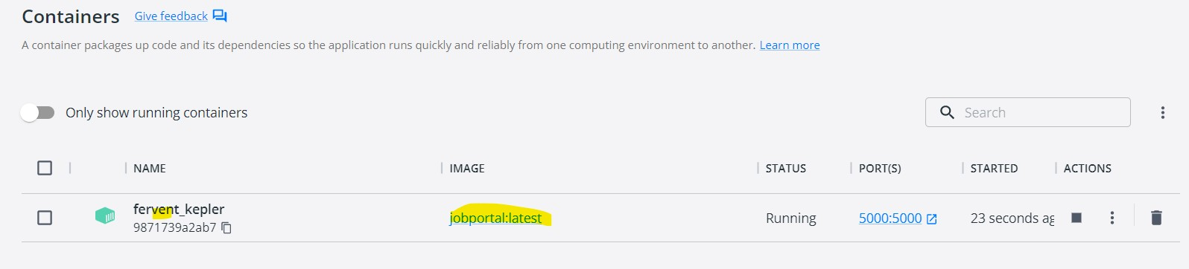

1. Create a IBM container registry and deploy helloword app or jobportal

